ANNUAL REPORT

CEIRIOG UCHAF COMMUNITY COUNCIL

2022-2023

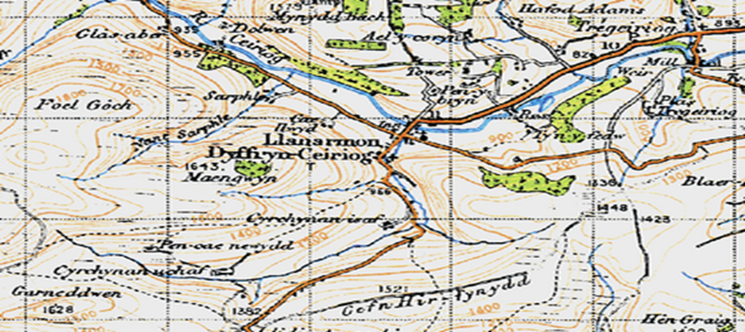

1 OUR ROLE in 2022-2023

To act as a voice for our local area.
To express the views of the community to local authorities and to act when in the interests of our community.
To represent our community.
To be partners, but not part of, wider local government.
Community Councils must represent all people in the area without prejudice.
We aim to be non-sectarian and inclusive.

2 THE COMMUNITY COUNCIL 2022-2023

Ceiriog Uchaf Community Council is the smallest Council in the Ceiriog Valley and the third smallest in the Wrexham County Borough. It represents two wards comprising of 162 homes from which our finances are derived - the ‘Precept’.

Llanarmon Ward
Cllr Dave Berriman | davetremyglog@gmail.com
Cllr Shimara Berriman | 01691 600974: shimaraberriman@gmail.com
Cllr Jane Claybrook | 07811 316 117: janeclaybrook70@hotmail.co.uk
Cllr Freja Evans Swogger | 07989 022486: frejafjes@gmail.com
Llangadwaldr Ward
Cllr Keith L Benning (Chair) | 07980 013577: klb60@btinternet.com
Cllr Glyn M Jones | 01691-600656 : Glanarfon, Tregeiriog
Cllr Eryl W Morris | 01691 600241: Ty Du, Tregeiriog
VACANCY

During the past year we have had one vacancy following a resignation and it is anticipated that an appointment will be made by May 2023.

The Council meets monthly, the first Tuesday of each month for 2 hours. All meetings are public and under recent legislation, there are few restrictions as to venue.

It considers a range of issues that directly effect the two Wards. All planning applications; improvements to the areas; roads; noise; pollution to the river, community needs and community concerns.

County Councillor Trevor Bates is a regular attendee and is our link into Wrexham CBC. Trevor can be contacted on Trevor.bates@wrexham.gov.uk

The Council has a limited power to make financial payments; 8% of last year’s income was donated to support local activities.

3 THE PEOPLE
PUBLIC MEETING – AFON CEIRIOG: In January 2023 the Council organised and hosted a public meeting with National Resources Wales to look at their work in clearing and re-populating the Ceiriog with trout. It gave residents an opportunity to talk directly with those doing the work.
COMMUNITY AGENT: We are very pleased to be developing a partnership with the Glyn Ceiriog Community Council in the extension of Christina Brewin’s role as ‘Community Agent’. Christina brings much experience and hopefully 400 extra hours a year of support and help into the Upper Valley. We hope that Wrexham CBC will confirm this appointment and funding in May 2023.
NORTH WALES POLICE: Our thanks to Martin and Gareth our local PCSOs for their on-going commitment to the area. Operation Blue Target was a significant police presence over a weekend to reduce the amount of anti-social road users which can blight our countryside.

4 PROPERTY AND PLACES
HUW MORUS MONUMENT Our thanks to Cllr Benning and the owners Martin and Gida Obbard for all the work in the restoration of the Huw Morus Monument at Pont y Meibion farm.
MOBILE COVERAGE AND THE ‘K6’ After years of campaigning by the Council, the Government is extending mobile coverage to the Upper Valley in 2023 and work is underway adapting the mast on the Cwm Road. BT has started to repair the K6 telephone box and they promise to re-paint it later this year.
THE FINGERPOST AND THE VILLAGE CENTRE Rosie and Rob Davies have made such a contribution to the beauty of the centre of Llanarmon DC over many years. The fingerpost has been restored and the flower boxes around it are wonderful.
THE ‘WARM HUB’ NOW THE ‘DROP-IN’: Thanks to Cllr Claybrook and Lorna Mills and many volunteers who started a weekly warm-hub attracting up to 15 people. This has been so successful that it will continue into the Spring and Summer as a weekly ‘Drop-In’.

6 PAPERWORK
Web-Site: Thanks to Cllr Freja Swogger and John Swogger for reviving the Council web-site this year: www.ceirioguchaf.co.uk. It has limitations in terms of photographs but provides up to date news of the Council’s activities and wider news from the two Wards.
Glyn News: The Editor Frank Griffiths is tireless in keeping this vital communication going along the Valley and our Council has a regular news slot each month.
Council Governance: As a responsible and well-managed Council we have a range of approved policies related to safeguarding, CCTV privacy, risk assessments, Welsh Language. In 2022 we approved an Annual Training Plan and a Bio-Diversity Policy.
5 PARTNERS in 2022-2023
Effective councils operate in partnership with other organisations and we are very pleased to have been linked to the following this year:
CADW (Huw Morus Grant); Glyn Ceiriog Community Coucnil (working jointly to bring the Community Agent into the Upper Valley. Ysgol Llanarmon, Memorial Institute and St Garmon’s PCC helping to plan for the Centenary. The Centenary Hall Committee in allowing events to take place, especially the Warm-Hub.
7 FINANCES
£ The annual precept is £6,000 – equal to £37 per household per year.
£ Accounts are audited by Brian Pratt and were submitted for the year to the 31/03/2022 and are awaiting approval by Audit Wales.
£ Provisional accounts up to 31/03/2023 which are subject to audit, are now available and attached.
£ A new ‘Determination’ came into operation last year allowing Councillors to be paid an expenses allowance for their attendance unless declined.

