CEIRIOG UCHAF COMMUNITY COUNCIL
CODE OF CONDUCT 2023

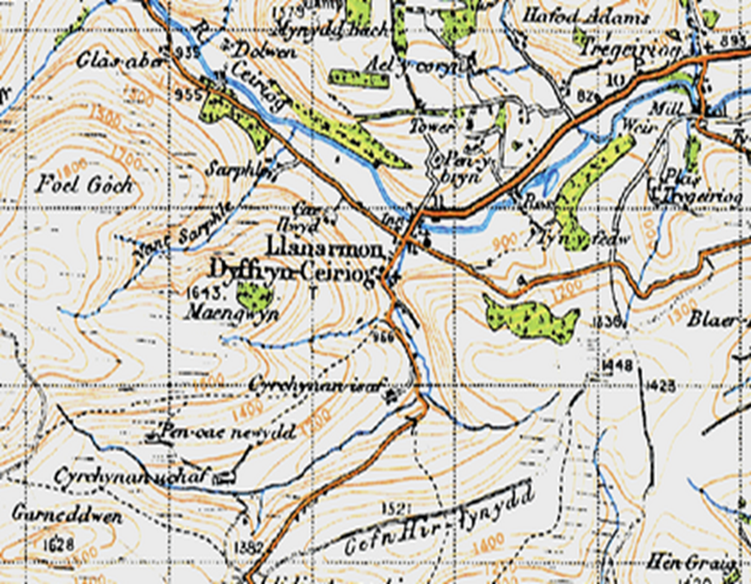

Introduction
The Ceiriog Uchaf Community Council seeks to adopt The Local Government Association (LGA) Model Councillor Code of Conduct,
All councils are required to have a local Councillor Code of Conduct.

Definitions
For the purposes of this Code of Conduct, a “councillor” means a member or co-opted member of a local authority or a directly elected mayor. A “co-opted member” is defined in the Localism Act 2011 Section 27(4) as “a person who is not a member of the authority but who a) is a member of any committee or sub-committee of the authority, or; b) is a member of, and represents the authority on, any joint committee or joint subcommittee of the authority; and who is entitled to vote on any question that falls to be decided at any meeting of that committee or sub-committee”.

Purpose of the Code of Conduct
The purpose of this Code of Conduct is to assist you, as a councillor, in modelling the behaviour that is expected of you, to provide a personal check and balance, and to set out the type of conduct that could lead to action being taken against you. It is also to protect you, the public, fellow councillors, local authority officers and the reputation of local government. It sets out general principles of conduct expected of all councillors and your specific obligations in relation to standards of conduct. The LGA encourages the use of support, training and mediation prior to action being taken using the Code. The fundamental aim of the Code is to create and maintain public confidence in the role of councillor and local government.

General principles of councillor conduct
Everyone in public office at all levels; all who serve the public or deliver public services, including ministers, civil servants, councillors and local authority officers; should uphold the Seven Principles of Public Life, also known as the Nolan Principles.
Building on these principles, the following general principles have been developed specifically for the role of councillor. In accordance with the public trust placed in me, on all occasions:
• I act with integrity and honesty
• I act lawfully
• I treat all persons fairly and with respect; and
• I lead by example and act in a way that secures public confidence in the role of councillor. In undertaking my role:
• I impartially exercise my responsibilities in the interests of the local community
• I do not improperly seek to confer an advantage, or disadvantage, on any person
• I avoid conflicts of interest
• I exercise reasonable care and diligence; and
• I ensure that public resources are used prudently in accordance with my local authority’s requirements and in the public interest.

Application of the Code of Conduct
This Code of Conduct applies to you as soon as you sign your declaration of acceptance of the office of councillor or attend your first meeting as a co-opted member and continues to apply to you until you cease to be a councillor.
This Code of Conduct applies to you when you are acting in your capacity as a councillor which may include when:
• You misuse your position as a councillor
• Your actions would give the impression to a reasonable member of the public with knowledge of all the facts that you are acting as a councillor;
The Code applies to all forms of communication and interaction, including:
• at face-to-face meetings
• at online or telephone meetings
• in written communication
• in verbal communication
• in non-verbal communication
• in electronic and social media communication, posts, statements and comments.
You are also expected to uphold high standards of conduct and show leadership at all times when acting as a councillor.

Standards of councillor conduct
This section sets out your obligations, which are the minimum standards of conduct required of you as a councillor. Should your conduct fall short of these standards, a complaint may be made against you, which may result in action being taken. Guidance is included to help explain the reasons for the obligations and how they should be followed.
1 Respect
As a councillor:
1.1 I treat other councillors and members of the public with respect.
1.2 I treat local authority employees, employees and representatives of partner organisations and those volunteering for the Community Council with respect and respect the role they play.
Respect means politeness and courtesy in behaviour, speech, and in the written word. Debate and having different views are all part of a healthy democracy. As a councillor, you can express, challenge, criticise and disagree with views, ideas, opinions and policies in a robust but civil manner. You should not, however, subject individuals, groups of people or organisations to personal attack.

2. Bullying, harassment and discrimination
As a councillor:
2.1 I do not bully any person.
2.2 I do not harass any person.
2.3 I promote equalities and do not discriminate unlawfully against any person.

The Advisory, Conciliation and Arbitration Service (ACAS) characterises bullying as offensive, intimidating, malicious or insulting behaviour, an abuse or misuse of power through means that undermine, humiliate, denigrate or injure the recipient. Bullying might be a regular pattern of behaviour or a one-off incident, happen face-to-face, on social media, in emails or phone calls, happen in the workplace or at work social events and may not always be obvious or noticed by others. The Protection from Harassment Act 1997 defines harassment as conduct that causes alarm or distress or puts people in fear of violence and must involve such conduct on at least two occasions. It can include repeated attempts to impose unwanted communications and

