Environment (Wales) Act 2016 Part 1 – Section 6
The Biodiversity and Resilience of Ecosystems Duty

Reporting on Section 6 – Reporting Template for Town and Community Councils

Environment (Wales) Act 2016 Part 1 - Section 6
The Biodiversity and Resilience of Ecosystems Duty Report 2022
CEIRIOG UCHAF COMMUNITY COUNCIL
Introduction and Context
Ceiriog Uchaf is one of the smaller Community Councils within the administration of Wrexham County Borough Council. Its geography includes two wards, Llanarmon DC and Langadwaldr and there are 8 Councillors.
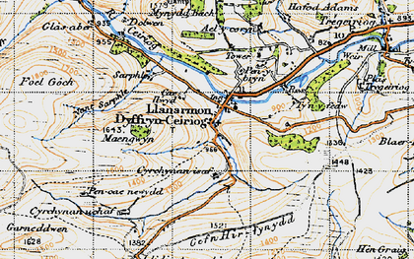
The landscape is given over to farming – principally sheep. The Precept is raised from 161 houses with less than 1000 residents.
The Council owns no land or property. We rent our meeting room.
The Council believes that it does not own either Graveyard or new Cemetery although this is the subject of enquiry. The Council does administer the Cemetery on behalf of Wrexham CBC.
The Council seeks to enhance biodiversity and resilience of its ecosystems in some of the following ways and this is reflected within its Inaugural Action Plan (2023).
- Talking with landowners and land users;
- Being aware of the impact of development;
- Liaising with Conservation and Environmental partners;
- Monitoring traffic;
- Developing safer transport routes within the Valley;
- Financial funding of initiatives linked to the Environment.

Action Report for 2023-2024
Action carried out to: |  | Monitored by:
-embed biodiversity into decision making & procurement | - To undertake an audit of the Graveyard and Cemetery to catalogue flora, fauna, and wildlife.  - To participate within the ‘God’s Acre’ project and to use the framework provided to collate and present information.  - To increase awareness through posters for Ysgol Llanarmon | God’s Acre Project team
-raise awareness of biodiversity & its importance | - On the 10th January 2023 the Council facilitated a public meeting for representatives from National Resources Wales to present and discuss with members of the public and landowners its work on the Afon Ceiriog. This is a vital life-force flowing through our administration. It provides a critical habitat which requires management.  - The Council has committed to facilitating a further Public Meeting in January 2024 to review the progress made by NRW.  - The Council will establish a page on its Website to the Environment, Bio-Diversity and Resilience of Eco-systems  - The Council will review its work in this area within its Annual Report each May. | The Clerk to organise a follow-up meeting in 2024.  Clerk  Clerk
-safeguard principal species and habitats | - National Resources Wales have committed to providing the Council with periodic data detailing the impact of their work along the Afon Ceiriog. The Council will ensure that this information is made available through meetings, Minutes and on its Website for residents within its administration.
-restore & create habitats and resilient ecological networks | - The Council will review its audit of the Graveyard and the Cemetery  - To develop a partnership with an expert in bird-ringing. | A designated meeting will be assigned for this review.
-tackle negative factors: for e.g. reduce pollution, use nature based solutions, address invasive species | - The Council has a duty to protect the environment through its representations to Wrexham CBC Planning. All new planning applications are scrutinised for their impact upon the environment and where appropriate, objections raised. | Council Meetings
-use improve and share evidence | - The Council will work with relevant partners to best determine the most effective presentation of data and evidence.
-support capacity and/or other organisations | - The Council is committed to working with principal partners:  - Wrexham Environmental Services;  - St Asaph Diocese  - Landowners  - The Chirk Estate
Review of s6 duty
This represents an inaugural report. It will be reviewed in February 2024
