**ANNUAL REPORT**

**CEIRIOG UCHAF COMMUNITY COUNCIL**

**2024-2025**

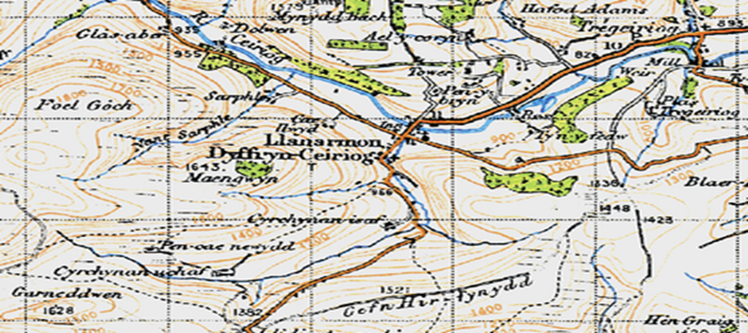

**1 OUR ROLE in 2024-2025**

**To act as a voice for our local area**.

**To express the views of the community to Local Authorities and to act when in the interests of our community.**

**To represent our community.**

**To be partners, but not part of, wider local government.**

**Community Councils must represent all people in the area without prejudice.**

**We aim to be non-sectarian and inclusive.**

**2 THE COMMUNITY COUNCIL 2024-2025**

Ceiriog Uchaf Community Council is the smallest Council in the Ceiriog Valley and the fourth smallest in the Wrexham County Borough. It represents two wards comprising of 160 homes from which our finances are derived - the ‘Precept’ which appears on the Council Tax bill each April.

|  |  |
| --- | --- |
| **Llanarmon Ward** | |
| Cllr Dave Berriman | davetremyglog@gmail.com |
| Cllr  Shimara Berriman | 01691 600974: shimaraberriman@gmail.com |
| Cllr Jane Claybrook | 07811 316 117: janeclaybrook70@hotmail.co.uk |
| Cllr Freja  Evans Swogger (Vice-Chair) | 07989 022486: frejafjes@gmail.com |
| **Llangadwaldr Ward** | |
| Cllr Keith L Benning (Chair) | 07980 013577: klb60@btinternet.com |
| Cllr Aled Jones | aledifanrobert@gmail.com |
| Cllr Glyn M Jones | 01691-600656 : Glanarfon, Tregeiriog |
| Cllr Eryl W Morris | 01691 600241: Ty Du, Tregeiriog |

The Council usually meet monthly, the first Tuesday, for 2 hours. All meetings are public and under recent legislation, there are few restrictions as to venue. The Council does have the right to hold a ‘Part 2’ meeting and it can restrict members of the public and the press if required.

It considers a range of issues that directly affect the two Wards. All planning applications; improvements to our shared local areas; roads; noise; environmental matters, community issues and community needs.

County Councillor **Trevor Bates** is a regular attendee and is our link into Wrexham CBC. Trevor can be contacted on **Trevor.bates@wrexham.gov.uk**

The Council has a limited power to make financial payments.

**4 PROPERTY AND PLACES**

**VILLAGES OF BEAUTY**. Our continued thanks to **Rosie and Rob Davies** who do so much work to maintain the centre with flower and plants and also to **Cllr Jane Claybrook** who has gone to further areas of our Wards.

**ENVIRONMENTAL GRANTS**: This year we introduced a small fund (£1,000) to award small grants to anyone with an idea to improve the two villages.

**GRAVEYARD AND CEMETERY**: These areas have been the focus of much attention and the Council’s thanks is extended to **St Garmon’s PCC** for their partnership. We are looking into the finances and feasibility of clarifying the on-going problems of ownership.

**THE COMMUNITY ‘HUB’.** This has grown out of the warm spaces initiativeThanks to **Cllr Claybrook** and the team of many volunteers who started a weekly warm-hub attracting a regular number to 15 people. The mobile library attends each month.

**3 THE PEOPLE**

**OUR RESIDENTS:** Each year we attempt to hold at least one public meeting and this years was held in November. Just over a 100 people attended to listen to arguments for and against the proposed North East Wales National Park. 97 people voted against and a record of the discussions was sent to National Resources Wales.

**COMMUNITY AGENT:** We were very pleased to announce a further extension of **Christina Brewin’s** role as ‘Community Agent’ to Llanarmon. Christina brings much experience and 400 extra hours a year of support and help into the Upper Valley.

**CITIZEN’S ADVICE OUTREACH:** Our thanks to Glyn Ceiriog Community Council and Christina for setting up a pilot outreach project for the Citizens Advice Bureau. The pilot ended in March 2025 and we are evaluating the results, but we know that a good number of our residents have taken advantage of this initiative.

**NORTH WALES POLICE**: Our thanks to **Martin and Gareth** our local PCSOs for their on-going commitment to the area. In the past year their roles have changed and we have less access to them for operational reasons.

**6 PAPERWORK**

**Website:** Please stay in touch with the Council through this means. We try to get out paper versions of decisions and meetings but the website will give quicker access.[www.ceirioguchaf.co.uk](http://www.ceirioguchaf.co.uk). It has limitations in terms of photographs but provides up to date news of the Council’s activities and wider news from the two Wards. Also find us on Facebook

**Glyn News:** The Editor **Frank Griffiths** is tireless in keeping this vital communication going along the Valley and our Council has a regular news slot each month.

**5 PARTNERS in 2024-2025**

Effective councils operate in partnership with other organisations and we are very pleased to have been linked to the following this year:

**Our Community Council Neighbours** for working to establish a 3-Council’ Valley meeting 3 times a year. **Ysgol Llanarmon**. **St Garmon’s PCC** inhelping us to plan for the ownership of the graveyard and cemetery.  **The Centenary Hall Committee** in allowing events to take place, especially the Community Hub.

**7 FINANCES**

**£** The annual precept is £10,000 – equal to £59 per Band D household per year. We notified our intention to raise this from last year’s £6,000 because we need to plan for the potential ownership of the cemetery and graveyard. We have now developed a small reserve which will go forward into the next financial year. We are planning to ask for a further £10,000 in this year’s Precept with a view to looking after the two resting places as befits our community.

**£** Accounts are audited by **Brian Pratt** and were submitted for the year to the 31/03/2024 and were approved by Audit Wales. Our thanks to Brian.

**£** Final accounts up to 31/03/2025 have been audited and await Council’s approval.