ANNUAL REPORT

CEIRIOG UCHAF COMMUNITY COUNCIL

2025-2026

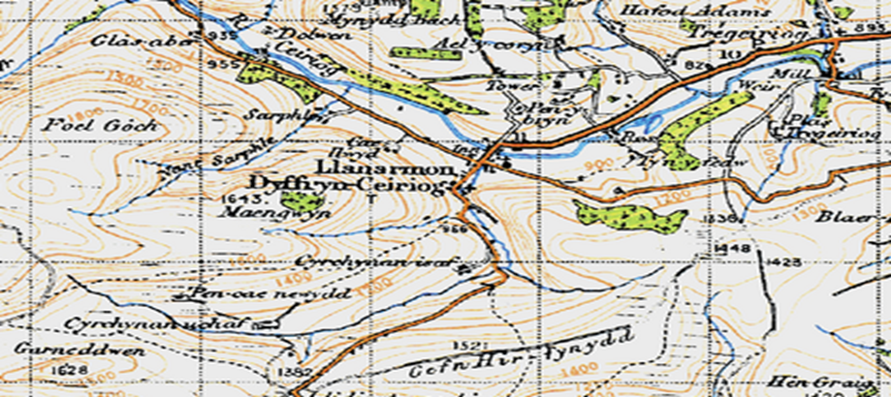

1 OUR ROLE in 2025-2026

To act as a voice for our local area.
To express the views of the community to Wrexham County Borough Council and to act when in the interests of our community.
To represent our community.
To be partners with, but not part of, wider local government.
Community Councils must represent all people in the area without prejudice.
We aim to be non-sectarian and inclusive.

2 THE COMMUNITY COUNCIL 2025-2026

Ceiriog Uchaf Community Council is the smallest Council in the Ceiriog Valley and the fourth smallest in the Wrexham County Borough. It represents two Wards comprising of 160 homes from where our finances are derived - the ‘Precept’. This which appears on the Council Tax bill each April.
This year we welcomed two new Councillors Cathy jones and Martin Obbard.

Llanarmon Ward
Cllr Jane Claybrook | janeclaybrook70@hotmail.co.uk
Cllr Cathy Jones | cathy_dwyrhos@hotmail.com
Cllr Martin Obbard | martinobbard@hotmail.com
Cllr Freja Evans Swogger (Chair of the Council) | frejafjes@gmail.com
Llangadwaldr Ward
Cllr Keith L Benning  (Vice-Chair of the Council) | klb60@btinternet.com
Cllr Aled Jones | aledifanrobert@gmail.com
Cllr Glyn M Jones | 01691-600656 Glanarfon, Tregeiriog
Cllr Eryl W Morris | 01691 600241: Ty Du, Tregeiriog

The Council usually meets monthly, the first Tuesday, for 2 hours. All meetings are public and under recent legislation, there are few restrictions as to venue. The Council does have the right to hold a ‘Part 2’ meeting and it can restrict members of the public and the press if required.

It considers a range of issues that directly affect the two Wards. All planning applications; improvements to our shared local areas; roads; noise; environmental matters, community issues and community needs.

County Councillor Trevor Bates is a regular attendee and is our link into Wrexham CBC. Trevor can be contacted on Trevor.bates@wrexham.gov.uk

The Council has a limited power to make small financial donations.

4 PROPERTY AND PLACES
VILLAGES OF BEAUTY. Our thanks to Rosie and Rob Davies who have passed over the trowel to Anne Wride. They have done so much to enhance the centre with flowers and plants. Also to Cllr Jane Claybrook who has gone to further areas of our Wards to plant and cultivate.
ENVIRONMENTAL GRANTS: Last year we introduced a small fund (£1,000) to award small grants to anyone with an idea to improve the two villages. In the second year, applications are growing and we agreed to spend 70% of the fund, distributing to local people and projects.
GRAVEYARD AND CEMETERY: These areas have been the focus of much attention and the Council’s thanks is extended to St Garmon’s PCC for their partnership. We are looking into the finances and feasibility of clarifying the long-term issues of ownership.
THE COMMUNITY ‘HUB’. This has grown out of the warm spaces initiative Thanks to Cllr Claybrook and the team of many volunteers who started a weekly warm-hub attracting a regular number to 15 people. The mobile library attends each month.
PLANNING MATTERS: The Council has worked closely with Wrexham in relation to several controversial and complex applications.

3 THE PEOPLE
OUR RESIDENTS: Each year we attempt to hold at least one public meeting and this year it was held in March to consider priorities for the ‘Pride in Place’ grant. Over 20 people attended to determine priorities for a grant, with refurbishment of the Village Hall floor being of greatest importance.
COMMUNITY AGENT: We were very pleased to announce a further extension of Christina Brewin’s role as ‘Community Agent’ to Llanarmon. Christina brings us much experience and 400 hours a year of support and help into the Upper Valley. As a Council we have taken responsibility to jointly fund her role from April 2027 given changes made by the Welsh Senedd.
NORTH WALES POLICE: Our thanks to Martin and Gareth our local PCSOs for their commitment to the area over many years and we welcome Naomi Tudor. Her first appearance at Council coincided with a debate about off-road biking and determining actions that North Wales Police can take

6 PAPERWORK
WEBSITE: Please stay in touch with the Council through this means. We try to get out paper versions of decisions and meetings but the website will give quicker access. www.ceirioguchaf.co.uk. This year we agreed to upgrade and in May the new version will go live with a better facility for photographs. Also find us on Facebook at Ceiriog Uchaf Community Council.
GLYN NEWS: The Editor Frank Griffiths is tireless in keeping this vital communication going along the Valley and our Council has a regular news slot each month.
5 PARTNERS in 2025-2026
Effective councils operate in partnership with other organisations and we are very pleased to have been linked to the following this year:
Our Community Council Neighbours: working to establish a 3-Council’ Valley meeting 3 times a year. Ysgol Llanarmon. St Garmon’s PCC in helping us to plan for the ownership of the graveyard and cemetery. The Centenary Hall Committee in allowing events to take place, especially the Community Hub. As a result of the Pride in Place grant, the Council is working closely with the Hall to draw in additional funding.
7 FINANCES
£ THE PRECEPT – THE ‘LOCAL TAX’ is £10,000 – equal to £61 per Band D household per year. We are planning for the potential transfer of ownership of the cemetery and graveyard and we are developing reserves for this. The Council approved that there would be no increase this year.
£ LAST YEAR’S ACCOUNTS were audited by Brian Pratt and submitted and were approved by Audit Wales. Our thanks to Brian.
£ THIS YEAR’S ACCOUNTS to 31/03/2026 have been provisionally audited and now await a full inspection by Audit Wales.
£ RESERVES: Planning for the future has required us to grow the reserves and the Council now holds £16,000 for future liabilities.

